Official (Open)


Software Engineering

Practical -
Software Engineering

Learning Outcomes:
- Describe the phases of SDLC
- Differentiate 3 Software Development approaches:
  - Waterfall
  - Iterative
  - Agile

Videos:
  - Intro to Scrum in Under 10 Minutes

Tasks:
Work as a team of 4-5 students, complete the following tasks:

- Manifesto for Agile Software Development

Fill in the blanks:

We are uncovering better ways of developing software by constantly improving upon it and helping others do it.
Through this work we have come to value:

Individuals and interactions over processes and tools
Working Software over comprehensive documentation
Customer Collaboration over contract negotiation
Responding to change over following a plan

That is, while there is value in the items on the right, we value the items on the left more.

- Based on the 12 principles of Agile Manifesto
(http://agilemanifesto.org/principles.html), what can you deduct from Agile approach to develop software? List 4 important things on which the Agile Principles emphasis.

Reference: How the 12 principles in the Agile Manifesto work

- Adopt to changes effectively
- Working software delivered frequently (weeks rather than months)
- Promotes teamwork and cross training
- Early feedback from users

24S1 Page 1 of 2

Official (Open)


Software Engineering

- What methodology to use? Fill up the blanks from A to D.

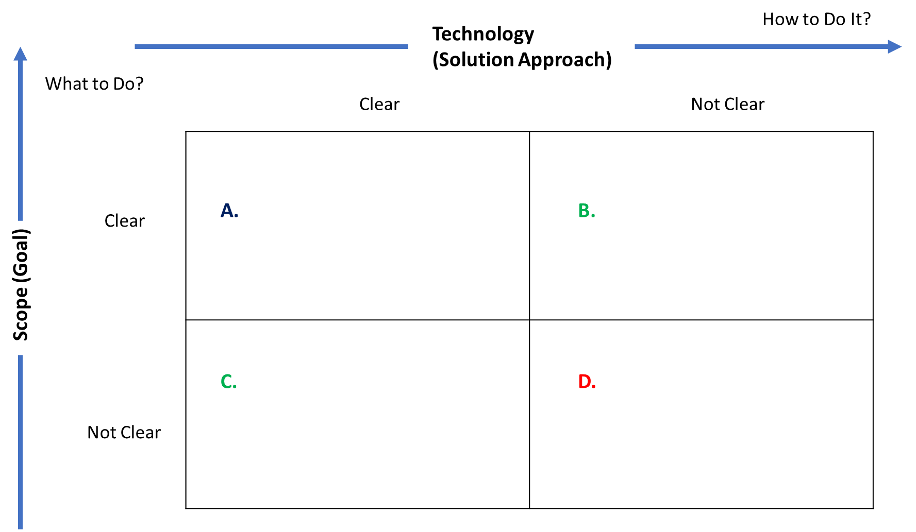

A: waterfall
B: agile development
C: agile development
D: Complex project Management

- The diagram below shows an overview of the SCRUM Framework. Fill up the missing labels from (a) to (e).

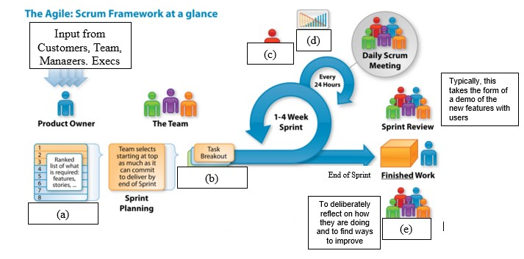

a)Product Backlog
b)Sprint backlog
c)Scrum Master
d)Burn Up/Down chart
e)Sprint retrospective

24S1 Page 2 of 2

